Answer 1 :-

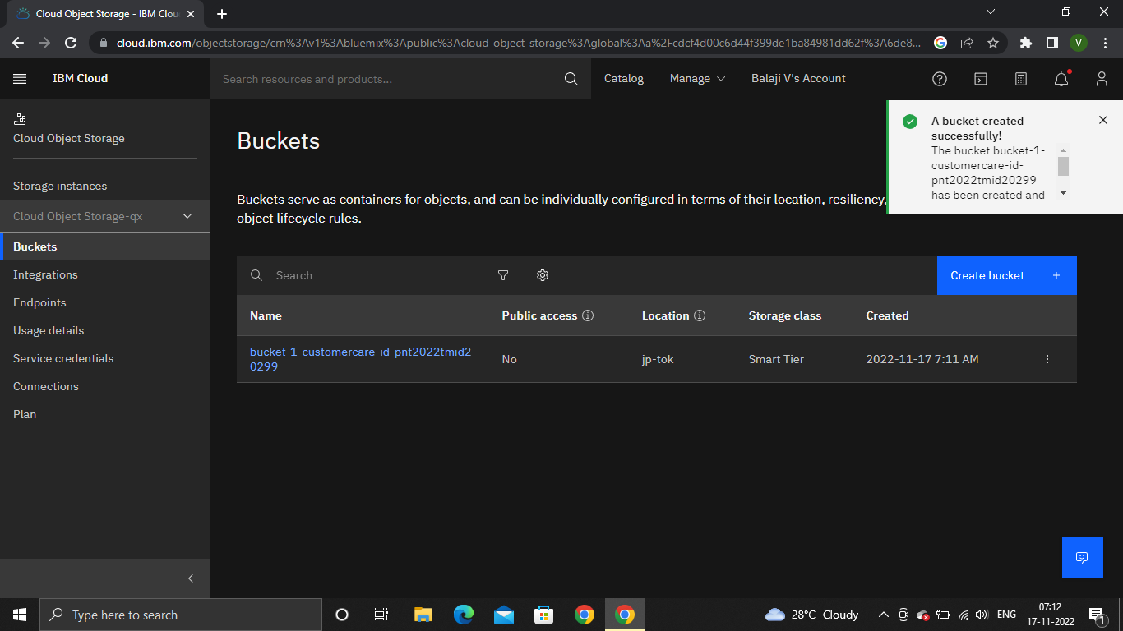

Answer 2 :-

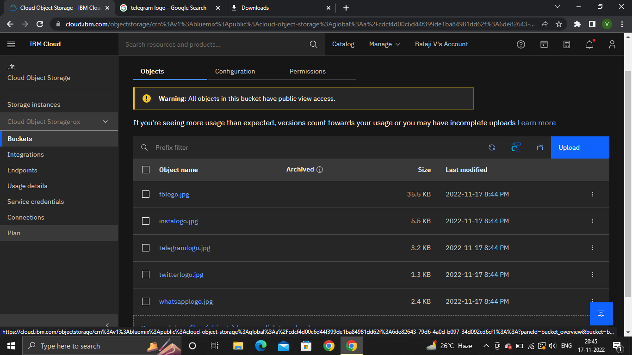

Answer 3 :-

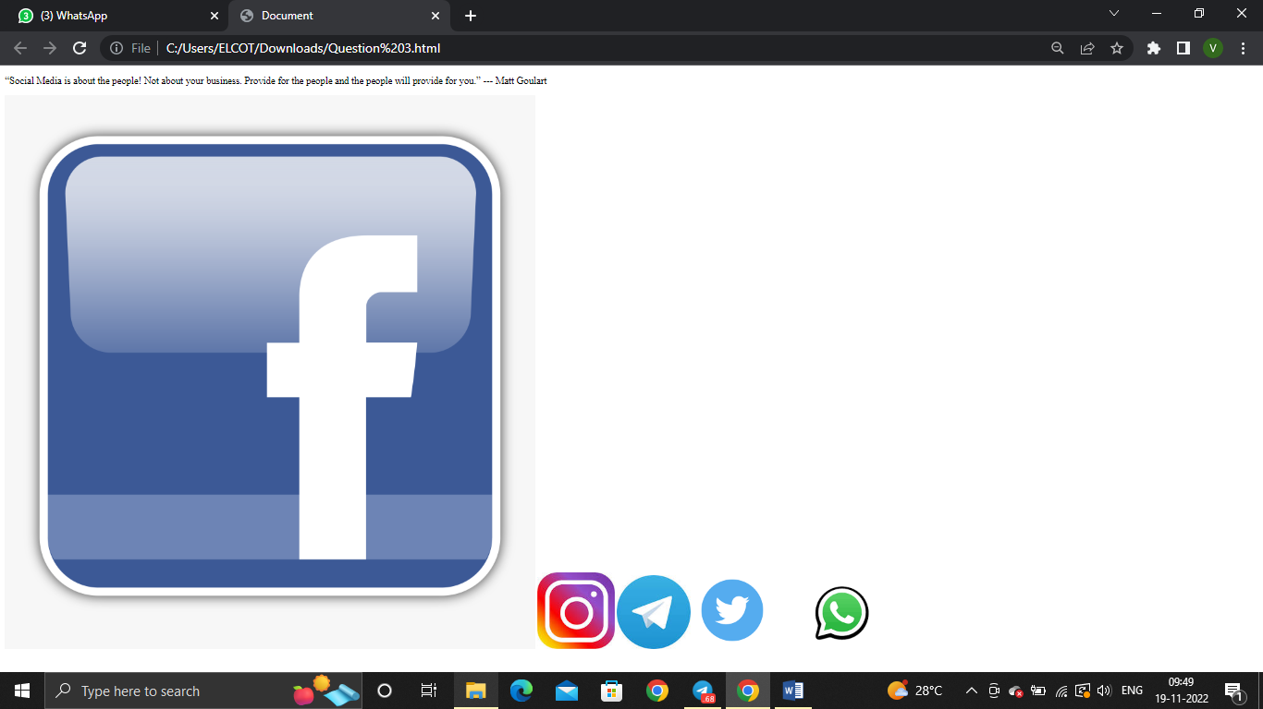

**HTML code :-**

<!DOCTYPE html>

<html lang="en">

<head>

    <meta charset="UTF-8">

    <meta http-equiv="X-UA-Compatible" content="IE=edge">

    <meta name="viewport" content="width=device-width, initial-scale=1.0">

    <title>Document</title>

    <link rel="stylesheet" href="style.css">

</head>

<body>

    <p>“Social Media is about the people! Not about your business. Provide for the people and the people will provide for you.” --- Matt Goulart

    </p>

    <img src="https://bucket-1-customercare-id-pnt2022tmid20299.s3.jp-tok.cloud-object-storage.appdomain.cloud/fblogo.jpg" alt="error on the cloud image check out this,height=600,border-width=500">

    <img src="https://bucket-1-customercare-id-pnt2022tmid20299.s3.jp-tok.cloud-object-storage.appdomain.cloud/instalogo.jpg" alt="error on the cloud image check out this,height=600,border-width=500">

    <img src="https://bucket-1-customercare-id-pnt2022tmid20299.s3.jp-tok.cloud-object-storage.appdomain.cloud/telegramlogo.jpg" alt="error on the cloud image check out this,height=600,border-width=500">

    <img src="https://bucket-1-customercare-id-pnt2022tmid20299.s3.jp-tok.cloud-object-storage.appdomain.cloud/twitterlogo.jpg" alt="error on the cloud image check out this,height=600,border-width=500">

    <img src= "https://bucket-1-customercare-id-pnt2022tmid20299.s3.jp-tok.cloud-object-storage.appdomain.cloud/whatsapplogo.jpg"alt="error on the cloud image check out this,height=600,border-width=500">

</body>

</html>

Answer 4 :-

LINK :-

https://web-chat.global.assistant.watson.appdomain.cloud/preview.html?backgroundImageURL=https%3A%2F%2Fau-syd.assistant.watson.cloud.ibm.com%2Fpublic%2Fimages%2Fupx-32971825-353d-453b-a9b8-2e12ad88a533%3A%3Ad901a5cf-acd4-4e8c-b4d2-d14ece585ae0&integrationID=7230ede3-f496-4c28-8229-7c0acc945d1b&region=au-syd&serviceInstanceID=32971825-353d-453b-a9b8-2e12ad88a533

Answer 5 :-

**HTML code :-**

<html>

  <body>

      <script>

  window.watsonAssistantChatOptions = {

    integrationID: "3TFs3PVYPlOMXJK8puAbwgPD6-3YAZE1lvMFoK50xbfC", // The ID of this integration.

    region: "au-syd", // The region your integration is hosted in.

    serviceInstanceID: "8dbb86a1-e3a7-43a1-9266-f2f8398cf7dd", // The ID of your service instance.

    onLoad: function(instance) { instance.render(); }

  };

  setTimeout(function(){

    const t=document.createElement('script');

    t.src="https://api.au-syd.assistant.watson.cloud.ibm.com/instances/d1ee85e6-6716-463a-8685-25bce11afad7" + (window.watsonAssistantChatOptions.clientVersion || 'latest') + "/WatsonAssistantChatEntry.js";

    document.head.appendChild(t);

  });

      </script>

  </body>

</html>